Uniaxial Tensile Testing

### AE351– Experiments in Aerospace Engineering (Structures)

ANKIT LAKHIWAL

January 22, 2021

**Note: Demonstration and Raw data collection are done by TA Mr. Vipin Chandra and he provided us related data in excel sheet.**

Objective 1

Introduction and Theory 1

Equipments 3

Procedure and Measurements 5

Results & Discussion 6

1. Sample Calculations **Error! Bookmark not defined.**

2. Data Presentation 6

3. Discussion and error analysis 8

Conclusion 8

Appendix 8

# Objective

The objective of this test is to analyse the nature of the specimen by stress-strain curves using Young’s modulus, yield stress, ultimate tensile stress, toughness and failure stress.

# Introduction and Theory

The uniaxial tension test provide a simple and effective way to characterize a material's response to loading.Therefore, to investigate material mechanics and gain experience in uniaxial testing, we performed tensile test on Aluminium alloy and calculated its Young’s modulus, yield stress, ultimate tensile strength, and failure stress.

To find out specimen propertie we will use following equation.

1. Engineering strain

ε = ΔL / Lo =( Lf - Lo) / Lo (1)

ΔL = change in length due to applied load

Lo = initial length of specimen

Lf = final length of specimen

1. Engineering Stress

σ = F / Ao (2)

F = Applied load to specimenb

Ao = Initial specimen gauge section area normal to the loading direction.

The maximum stress and strain for the uniaxial tension tests were determined by finding the local maximum of the stress-strain curve before fracture of the samples occurred.

1. Ultimate Tensile Stress

σuts = Fmax / Ao  (3)

The material initially behaves in a linear elastic manner: stress and strain are linearly related, and on unloading, the deformation is recoverable. The slope within the linear elastic regime is Young’s modulus, or the ratio of the engineering stress to engineering strain in the axis:

1. Young’s modulus

E = ( σ / ε )linear elastic region (4)

An example of the engineering stress-strain curve for a typical engineering alloy is shown in Image 1. From it some very important properties can be determined. The elastic modulus, the yield strength, the ultimate tensile strength, and the fracture strain are all clearly exhibited in an accurately constructed stress strain curve.

#### 

Image 1: stress vs. strain curve

**Elastic region**: The part of the stress-strain curve up to the yielding point. Elastic deformation is recoverable.In the elastic region stress and strain are related to each other linearly.E is Modulus of Elasticity or Young Modulus which is specific for each type of material.

Hooke’s Law: σ = EƐ

**Plastic region**: The part of the stress-strain diagram after the yielding point. At the yielding point, the plastic deformation starts. Plastic deformation is permanent. At the maximum point of the stress-strain diagram (σuts),necking starts.

# Equipments

* Universal Testing Machine (UTM)

Manufactured by Tinius Olsen, the UTM is a machine used for performing

stress/strain tests on materials. Although in the experiment we used it for uniaxial testing, it can perform multi-component stress analysis as well.

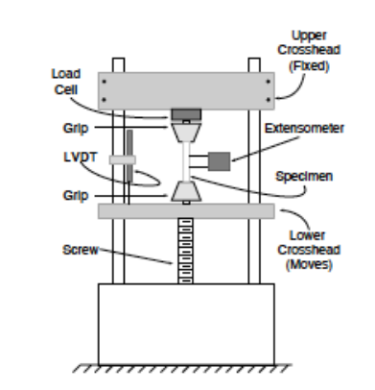

Image 2: Universal Testing Machine

* Computer System

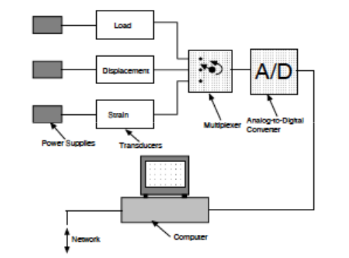

Image 3: Data aquisition model

* Extensometer

An extensometer is a device that is used to measure changes in the length of an object. It is useful for stress-strain measurements and tensile tests.

* Dog-bone shape Alumininum alloy (6000 series) specimen

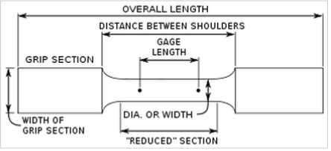

Image 4: Dog-bone shape specimen

# Procedure and Measurements

Intial measurment of Dog-bone shape specimen:

|  |  |  |
| --- | --- | --- |
| Material | initial gauge section diameter (Do) | initial gauge section length (Lo) |
| Aluminium Alloy | 6mm | 55m |

Table 1: Initial gauge dimension

Switched on the 15 kN Tinius Olsen universal testing machine (UTM). Then we hold the dog-bone shaped test specimen at the UTM grips and carefully mounted 25 mm extensometer in between the gage length region of the specimen. Loaded the specimen in displacement control mode at the speed of 1mm/min.

Then we recorded data with help of software till the extensometer strain value reached to 0.2%. Then we removed the extensometer and continue loading the specimen until specimen fractured.Specimen broke, but not exactly at middle of length.

# Results & Discussion

## Data Presentation

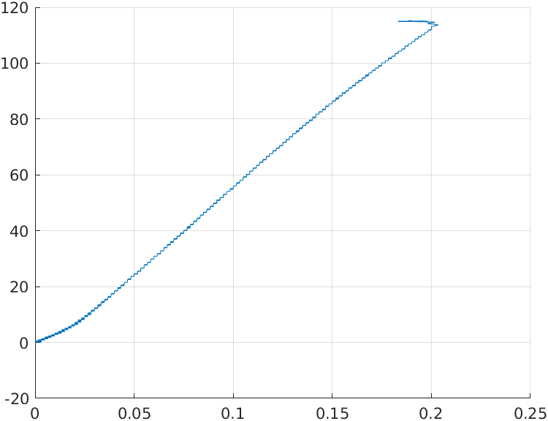

Graph 1 : stress vs extensometer strain

**Experimental Values from stress-strain(Extensometer) curve(*graph1*)**

Young’s Modulus, E = slope of Graph 1 = 62.42GPa

|  |  |  |  |
| --- | --- | --- | --- |
| Young’s Modulus (E) | Ultimate tensile stress (σuts) | Yield stress  (Yf) | Failure stress (σfailure) |
| 62.42GPa | 218.4MPa | 144MPa | 60.41MPa |

Table 2 : final specimen properties

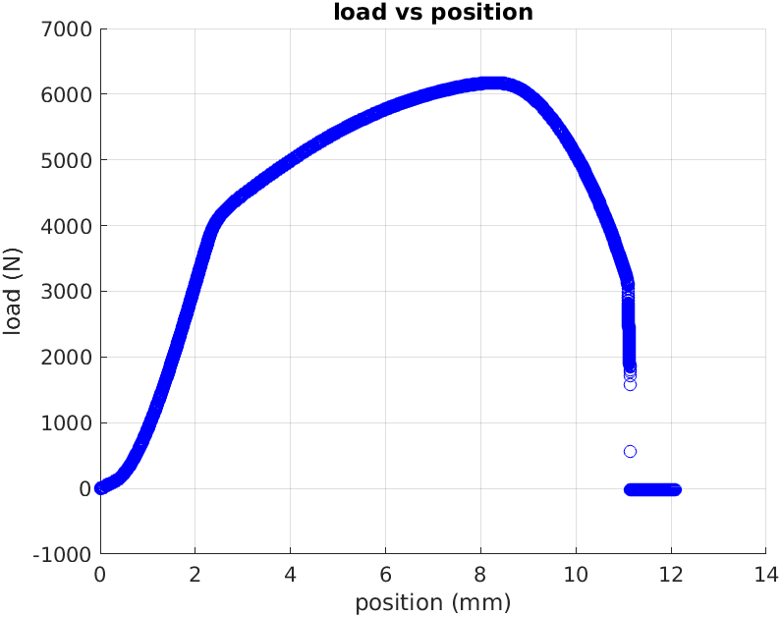

Graph 2: load vs position

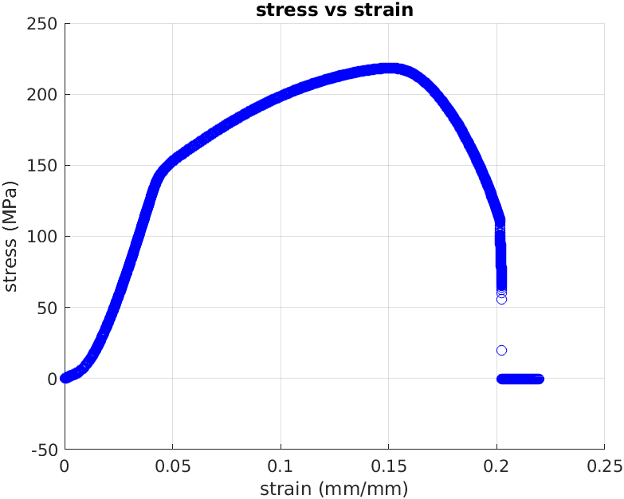

Graph 3: stress vs strain

**Experimental Values from stress-strain curve(*graph3*)**

Ultimat tensile stress, σuts : 218.4 MPa

Yield stress, Yf : 144Mpa

Failure stress, σfailure :60.41MPa

## 

## Discussion and error analysis

**Theoritical Value of Aluminium**

Ultimat tensile stress : 310 MPa

Yield stress : 276 MPa

Failure stress : 96.5MPa

Young’s Modulus :70GPa

**Error Calculation**

**% Error in Young Modulus = (70-62.42)/70 = 10.85%**

**% Error in Yiels stress = (276-144)/276 = 47.8%**

**% Error in Failure stress = (96.15-60.41)/96.15 = 37.17%**

**%Error in Ultimate stress= (310-218.4)/310 = 29.54%**

# Conclusion

There is %error in yield stress(47.8%), young modulus(10.85%), ultimate tensile stress(29.54%) and failure stress(37.17%) betweeen theoritical and exeperimental values, this is due to specimen impurities, temprarure variation and some other mechanical handelling.

# Appendix

[Raw Data](-1432056791.xlsx)